Karan kumar S

210519104045

**Question :**

Write a code and connections in wokwi for the ultrasonic sensor. Whenever the distance is less than 100cms send an “Alert” to IBM cloud and display in the device recent events.

**Code:**

#include <WiFi.h>  
#include <PubSubClient.h>  
void callback(char* subscribetopic, byte* payload, unsigned int payloadLength);  
//-------credentials of IBM Accounts------  
#define ORG "hhtffz"//IBM ORGANITION ID  
#define DEVICE_TYPE "EPS32_1"//Device type mentioned in ibmwatson IOT Platform

#define DEVICE_ID "BME280"//Device ID mentioned in ibm watson IOT Platform

#define TOKEN "QKLKK!6XDC3FnI5@+6" //Token  
String data3;  
char server[] = ORG ".messaging.internetofthings.ibmcloud.com";  
char publishTopic[] = "iot-2/evt/Data/fmt/json";  
char subscribetopic[] = "iot-2/cmd/test/fmt/String";  
char authMethod[] = "use-token-auth";

char token[] = TOKEN;  
char clientId[] = "d:" ORG ":" DEVICE_TYPE ":" DEVICE_ID; WiFiClient wifiClient;  
PubSubClient client(server, 1883, callback ,wifiClient); const int trigPin = 5;  
const int echoPin = 18;  
#define SOUND_SPEED 0.034  
long duration;  
float distance;  
void setup() {  
**Serial**.begin(115200);  
pinMode(trigPin, OUTPUT);  
pinMode(echoPin, INPUT);  
wificonnect();  
mqttconnect();  
}  
void loop()  
{  
digitalWrite(trigPin, LOW);  
delayMicroseconds(2);  
digitalWrite(trigPin, HIGH);  
delayMicroseconds(10);  
digitalWrite(trigPin, LOW);  
duration = pulseIn(echoPin, HIGH);  
distance = duration * SOUND_SPEED/2; **Serial**.print("Distance (cm): "); **Serial**.println(distance);  
if(distance<100)  
{  
**Serial**.println("ALERT!!");  
delay(1000);

PublishData(distance);

delay(1000);  
if (!client.loop()) {  
mqttconnect();  
}  
}  
delay(1000);  
}  
void PublishData(float dist) {  
mqttconnect();  
String payload = "{\"Distance\":";  
payload += dist;  
payload += ",\"ALERT!!\":""\"Distance less than 100cms\""; payload += "}";  
**Serial**.print("Sending payload: "); **Serial**.println(payload);

if (client.publish(publishTopic, (char*) payload.c_str())) { **Serial**.println("Publish ok");  
} else {  
**Serial**.println("Publish failed");

}  
}  
void mqttconnect() {  
if (!client.connected()) {  
**Serial**.print("Reconnecting client to "); **Serial**.println(server);  
while (!!!client.connect(clientId, authMethod, token)) { **Serial**.print(".");  
delay(500);  
}

initManagedDevice();

**Serial**.println();  
}  
}  
void wificonnect()  
{  
**Serial**.println(); **Serial**.print("Connecting to "); WiFi.begin("Wokwi-GUEST", "", 6); while (WiFi.status() != WL_CONNECTED) { delay(500);

**Serial**.print(".");  
}  
**Serial**.println(""); **Serial**.println("WiFi  
connected"); **Serial**.println("IP address: ");  
**Serial**.println(WiFi.localIP());  
}  
void initManagedDevice() {  
if (client.subscribe(subscribetopic)) {  
**Serial**.println((subscribetopic)); **Serial**.println("subscribe to  
cmd OK");  
} else {  
**Serial**.println("subscribe to cmd FAILED");  
}  
}  
void callback(char* subscribetopic, byte* payload, unsigned int payloadLength) {  
**Serial**.print("callback invoked for topic: ");  
**Serial**.println(subscribetopic);  
for (int i = 0; i < payloadLength; i++) {

//Serial.print((char)payload[i]);

data3 += (char)payload[i];  
}  
**Serial**.println("data: "+ data3); data3="";

}

**Diagram.json:**

{  
"version": 1,  
"author": "sweetysharon", "editor": "wokwi", "parts": [

{ "type": "wokwi-esp32-devkit-v1", "id": "esp", "top": -4.67, "left": -114.67, "attrs": {} },

{ "type": "wokwi-hc-sr04", "id": "ultrasonic1", "top": 15.96, "left": 89.17, "attrs": {} } ],

"connections": [  
[ "esp:TX0", "$serialMonitor:RX", "", [] ], [ "esp:RX0", "$serialMonitor:TX", "", [] ], [

"esp:VIN",  
"ultrasonic1:VCC",  
"red",  
[ "h-37.16", "v-178.79", "h200", "v173.33", "h100.67" ]

],  
[ "esp:GND.1", "ultrasonic1:GND", "black", [ "h39.87", "v44.04", "h170" ] ], [ "esp:D5", "ultrasonic1:TRIG", "green", [ "h54.54", "v85.07", "h130.67" ] ], [ "esp:D18", "ultrasonic1:ECHO", "green", [ "h77.87", "v80.01", "h110" ] ]

] }

**Wokwi simulation link:**

<https://wokwi.com/projects/347771967463490130>

**Circuit Diagram:**

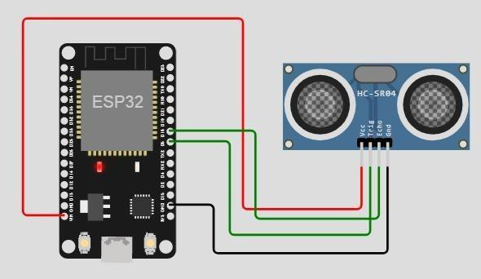

**Output:**

Wokwi output:

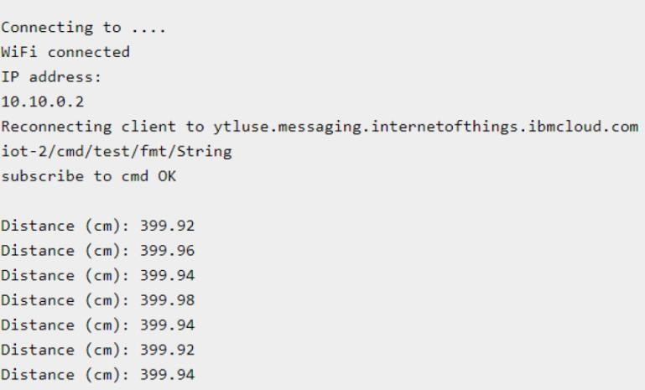

**IBM cloud output:**

